WGU Catalog Parsing for Reddit Analytics
Purpose:
This document explains how course data was scraped from WGU institutional catalogs to support Reddit analytics. It supports:
- LLM classification by enriching posts with course titles to provide context.
- Filtering by associating each course with its College and Program for segmentation.

1. Dataset Overview
- Path:
/Users/buddy/Desktop/WGU-Reddit/data/wgu_catalog_program_map_2025_06.json
- Contents:
Normalized records of:
  - College
  - Degree Program
  - Course Code (e.g., D502)
  - Course Title
- Source:
Catalogs archived from 2017-01 to 2025-06
URL: https://www.wgu.edu/about/institutional-catalog.html

2. Why Use Course Codes
- Avoid Ambiguity: Course titles are often abbreviated in informal social media posts. Keyword matching is unreliable.
- Handle Deprecation: Older, deprecated courses may share similar or identical titles with updated versions. Course codes clearly distinguish them.
- Consistency: Course codes are the primary reference used in Reddit posts and WGU systems, making them ideal for filtering and classification.

3. Scraping Process

3.1 Catalog Acquisition
- PDFs downloaded from WGU Institutional Catalog
- Converted to .txt (PDFPlumber)
- Parsed via a custom Python pipeline using deterministic logic

4. Catalog Structure

4.1 Default Layout
Each catalog organizes course data under the Academic Programs section, under:
- College
- Degree or Certificate Program
- Course Table

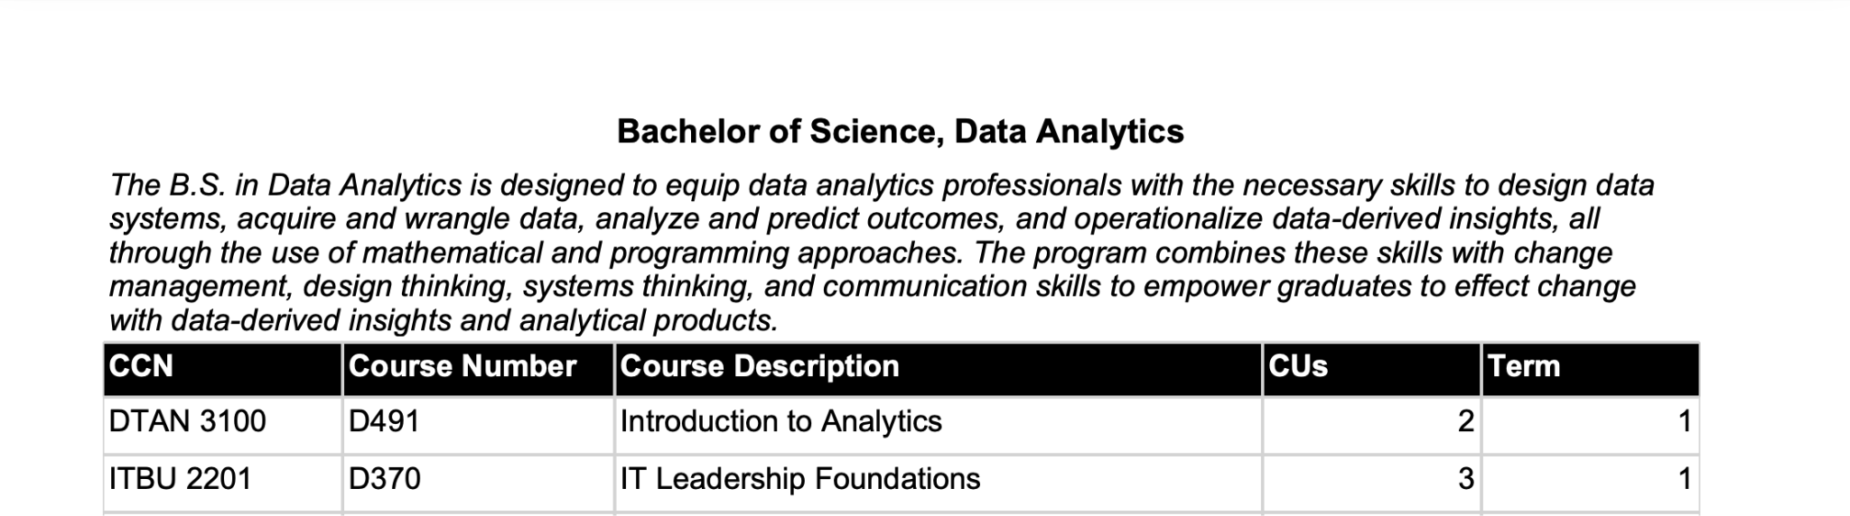
…….
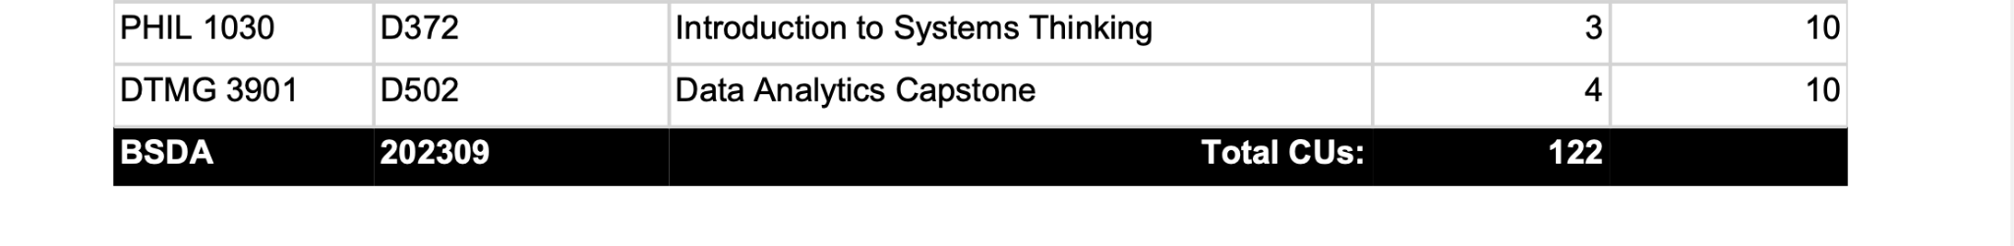
Course tables start with the header:
CCN Course Number…
and end with the line:
Total CUs

4.2 Structural Changes Over Time
- 2020-11: College Tenets section added before programs
- 2024-09:
  - Program Outcomes section replaces course descriptions (contains no course data)
  - Certificates moved to a separate “Certificates - Standard Paths” block, treated as a pseudo-college

5. Parsing Logic

5.1 General Approach
- Used regex-based fences to isolate course tables
- Parsing done only within trusted College and Program blocks

5.2 Key Regex Patterns

Primary Pattern
Used to anchor rows that begin with a valid course prefix followed by a 4-digit CCN.
^[A-Z]{2,5}[0-9]{0,3}\s+\d{4}
Matches:
- DTMG 3901 D502 Data Analytics Capstone 4 10
Parsed:
- Course Code: DTMG
- Title: 3901 D502 Data Analytics Capstone
- CUs: 4
- Term: 10

Fallback Pattern
Used for rows without CCNs (common in certificates):
^([A-Z]{2,5}[0-9]{0,3})\s+(.+?)\s+(\d+)\s+(\d+)$
Example:
- PM4 Project Management Capstone 1 1
Parsed:
- Course Code: PM4
- Title: Project Management Capstone
- CUs: 1
- Term: 1

6. Validation Notes
- Spot-checked via manual inspection of codes and titles
- Uses deterministic parsing rules with strict fences
- Not yet validated against internal WGU systems

7. Summary Statistics
- Colleges: 4
- Certificates (pseudo-college): 1
- Total College Programs: 124
- Total Certificate Programs: 16
- Total Unique Course Codes: 717
College Names:
- School of Business
- Leavitt School of Health
- School of Technology
- School of Education
- Certificates – Standard Paths

8. Final Notes
While catalogs from 2017-01 to 2025-06 were scraped and archived, only the most recent catalog was used in Reddit analysis. This ensures course references align with current student experiences and advice.

Future Opportunities
- Build a GUI for students to select a major and view course details.
- Expand Reddit analysis to other catalog areas:
  - Admissions
  - Tuition
  - Financial Aid
  - Academic Policies
  - Transfer Credit Guidelines

